**Potato Leaf Disease Classification Using Convolutional Neural Networks**

**Abstract**

This project utilizes Convolutional Neural Networks (CNNs) to classify potato leaf images into Early, Late, and Healthy categories. By leveraging image augmentation and efficient data pipeline techniques, this model aims to provide accurate and robust disease detection to aid early intervention and reduce crop loss. The model is trained and evaluated on a dataset of potato leaf images, achieving promising accuracy across train, validation, and test splits. This document outlines the development process, from data preparation to evaluation, concluding with insights and future work directions.

**Introduction**

The health of crops is essential for food security, and potato plants are vulnerable to diseases like Early Blight and Late Blight, which significantly impact yield. Traditional disease identification requires expertise and can be time-consuming. With advancements in machine learning, CNNs offer a promising solution to detect diseases through image classification. This project applies a CNN model to classify potato leaf images, automating the identification of common potato diseases and providing a scalable tool for farmers and agricultural experts.

**About the Diseases**

**Potato Blight (Late Blight)**

Potato blight, also known as late blight, is a devastating disease caused by the pathogen *Phytophthora infestans*, which spreads quickly through foliage and tubers in warm, wet weather. This disease causes rapid decay in potatoes and tomatoes and can sometimes affect ornamental plants within the *Solanum* genus. It remains one of the most damaging diseases for potato crops worldwide.

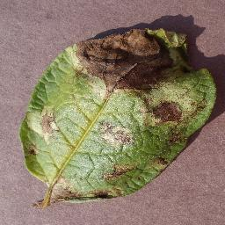

Potato leaf affected by Late Blight

**Early Blight**

Early blight, caused by *Alternaria solani* and *Alternaria alternata*, is more prevalent in North America. Though less common in other regions, it can be mistaken for nutrient deficiencies due to similar symptoms.

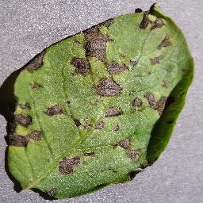

Potato leaf affected by Early Blight

**Data Collection**

Collecting and annotating data for training a CNN model can be time-consuming and costly, especially when done manually. Manual data collection requires significant resources, including time, equipment, and labor, and accurate annotation can add to the complexity and expense. Purchasing labeled data from third-party providers is also an option, but this can become expensive, particularly for high-quality, extensive datasets.

To mitigate these costs and ensure access to a reliable dataset, I utilized the **Plant Village** dataset from [Kaggle](https://www.kaggle.com/datasets/arjuntejaswi/plant-village). This dataset provides high-quality images of various plant diseases, including potato leaves affected by blight. It contains three labels: **early blight**, **late blight**, and **healthy**, making it ideal for training a model focused on detecting and distinguishing between different stages of blight and healthy plants. Using this dataset helped reduce the time and cost of manual data collection and annotation, allowing for efficient model training and evaluation.

**Methodology**

1. **Data Collection and Preparation**
   * The dataset, containing images categorized into three classes (Early Blight, Late Blight, and Healthy), is loaded and preprocessed.
   * Images are resized to 256x256 pixels and batched for efficient processing, with a batch size 32.
   * Dataset is partitioned into training (80%), validation (10%), and testing (10%) splits using TensorFlow functions to ensure model generalization. The dataset is split into training, validation, and testing subsets using TensorFlow functions like take and skip.
2. **Data Augmentation and Preprocessing**
   * Image preprocessing includes resizing and rescaling, ensuring each pixel value is normalized by dividing by 255.
   * Augmentation techniques, including random flipping and rotation, are applied to introduce variability and prevent overfitting.
3. **CNN Model Architecture**
   * The CNN model comprises six convolutional layers with ReLU activation functions, followed by max-pooling layers for dimensionality reduction.
   * **Convolution Layer**

The convolutional layer is essential for detecting patterns in images. It utilizes multiple filters (kernels) that slide across the input image and perform element-wise dot products with the pixel values. Each filter is designed to recognize specific features, such as edges or textures. Collectively, these filters capture complex features, enabling the model to understand the nuances of the input images.

* + **Max Polling Layer**

After convolution, the max pooling layer reduces the dimensionality of the feature maps by dividing them into regions (e.g., 2x2 grids) and taking the maximum value from each region. This operation retains the most prominent features while decreasing the computational load, making the model more efficient. Additionally, max pooling introduces some translation invariance, allowing the model to be less sensitive to the exact location of features.

* + **Fully Connected Layer and Softmax Activation**

Following the pooling layers, a fully connected (dense) layer integrates the learned features to perform classification. Each neuron in this layer is connected to all neurons in the previous layer, allowing it to synthesize information across all detected features.

To produce class probabilities, the model employs the **softmax activation function**. Softmax normalizes the output scores into a probability distribution across the three classes (Early Blight, Late Blight, and Healthy), ensuring that the sum of probabilities equals 1. This makes it suitable for multiclass classification tasks.

* + **Relu Activation Function**

The model utilizes the **Rectified Linear Unit (ReLU)** activation function after each convolutional layer. ReLU is defined as f(x)=max(0,x) effectively allowing positive values to pass through while setting negative values to zero. This property introduces non-linearity into the model, enabling it to learn complex patterns.

ReLU works exceptionally well in CNNs due to its computational efficiency and ability to mitigate the vanishing gradient problem, which can occur with traditional activation functions like sigmoid or tanh. As a result, CNNs with ReLU activation can converge faster and perform better, particularly in deep architectures.

1. **Training and Optimization**
   * The model is compiled with the Adam optimizer and Sparse Categorical Crossentropy as the loss function.
   * **Adam Optimizer**

Adam (Adaptive Moment Estimation) is an advanced optimization algorithm that combines the benefits of two other popular optimizers: AdaGrad and RMSProp.

* + - **Adaptive Learning Rates:** Adam adjusts the learning rate for each parameter individually, which allows it to converge faster and more efficiently across different scales of gradients.
    - **Momentum:** Adam helps accelerate updates in the relevant direction by incorporating momentum. This results in smoother convergence and improved performance on complex datasets.

Overall, the Adam optimizer is well-suited for training deep learning models, as it balances the speed of convergence with stability.

* + **Sparse Categorical Crossentropy**

Sparse Categorical Crossentropy is the loss function chosen for this model because it is designed for multiclass classification problems where each input belongs to one of several classes. In this case, the classes are Early Blight, Late Blight, and Healthy.

* + - **Label Representation:** Unlike Categorical Crossentropy, which requires one-hot encoding of the labels, Sparse Categorical Crossentropy allows the use of integer labels directly. This simplifies the preprocessing of labels, especially when dealing with many classes.
    - **Effective Multiclass Handling:** This loss function computes the cross-entropy loss between the predicted probability distribution (from the softmax output) and the true class labels, making it effective in scenarios with more than two classes.
  + It is trained over 100 epochs, with the training and validation progress tracked to monitor convergence and prevent overfitting.
  + The data pipeline is optimized using caching, shuffling, and prefetching for faster data access.
    - The cache() method stores the dataset in memory after the first pass, reducing load time for subsequent epochs.
    - The shuffle() function randomly rearranges the dataset, ensuring that the model does not see the data in the same order each epoch, which helps improve generalization.
    - The prefetch() function allows the data loading to occur in the background while the model is training, reducing idle time and improving throughput.

1. **Model Saving**
   * The trained model is saved in a versioned directory structure, allowing for model management and easy deployment.

**Model Evaluation**

1. **Accuracy and Loss**
   * The model's training, validation accuracy, and loss are tracked across epochs, with plots visualizing these metrics to assess performance stability and identify any overfitting or underfitting.

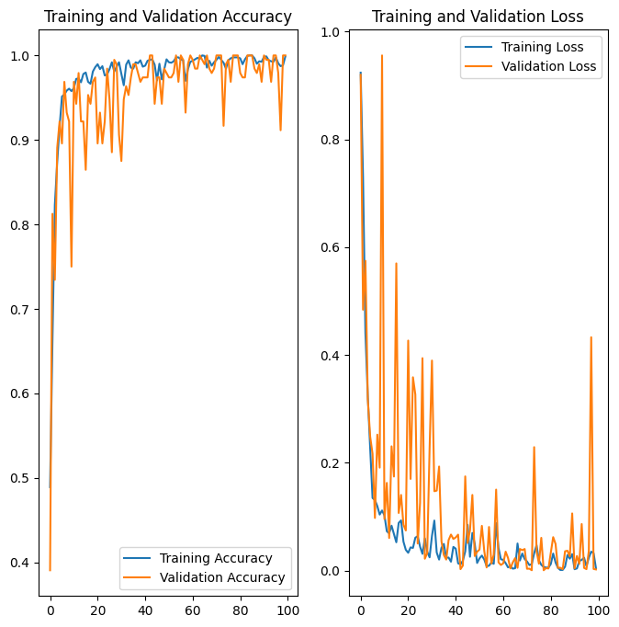

1. **Confusion Matrix**
   * A confusion matrix provides a detailed breakdown of true and predicted classes for the test dataset, highlighting the model's strengths and any misclassifications among the disease classes; **scikit-learn** and **seaborn** were used to generate and visualize the confusion matrix.

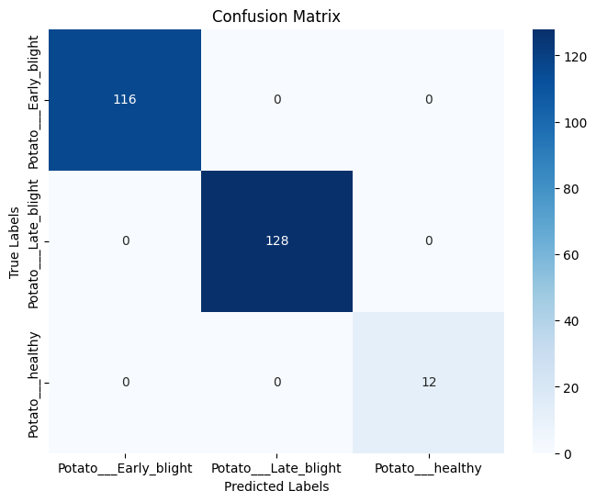

1. **Performance Metrics**
   * The overall test accuracy is measured, giving a quantitative insight into the model's reliability for unseen data.

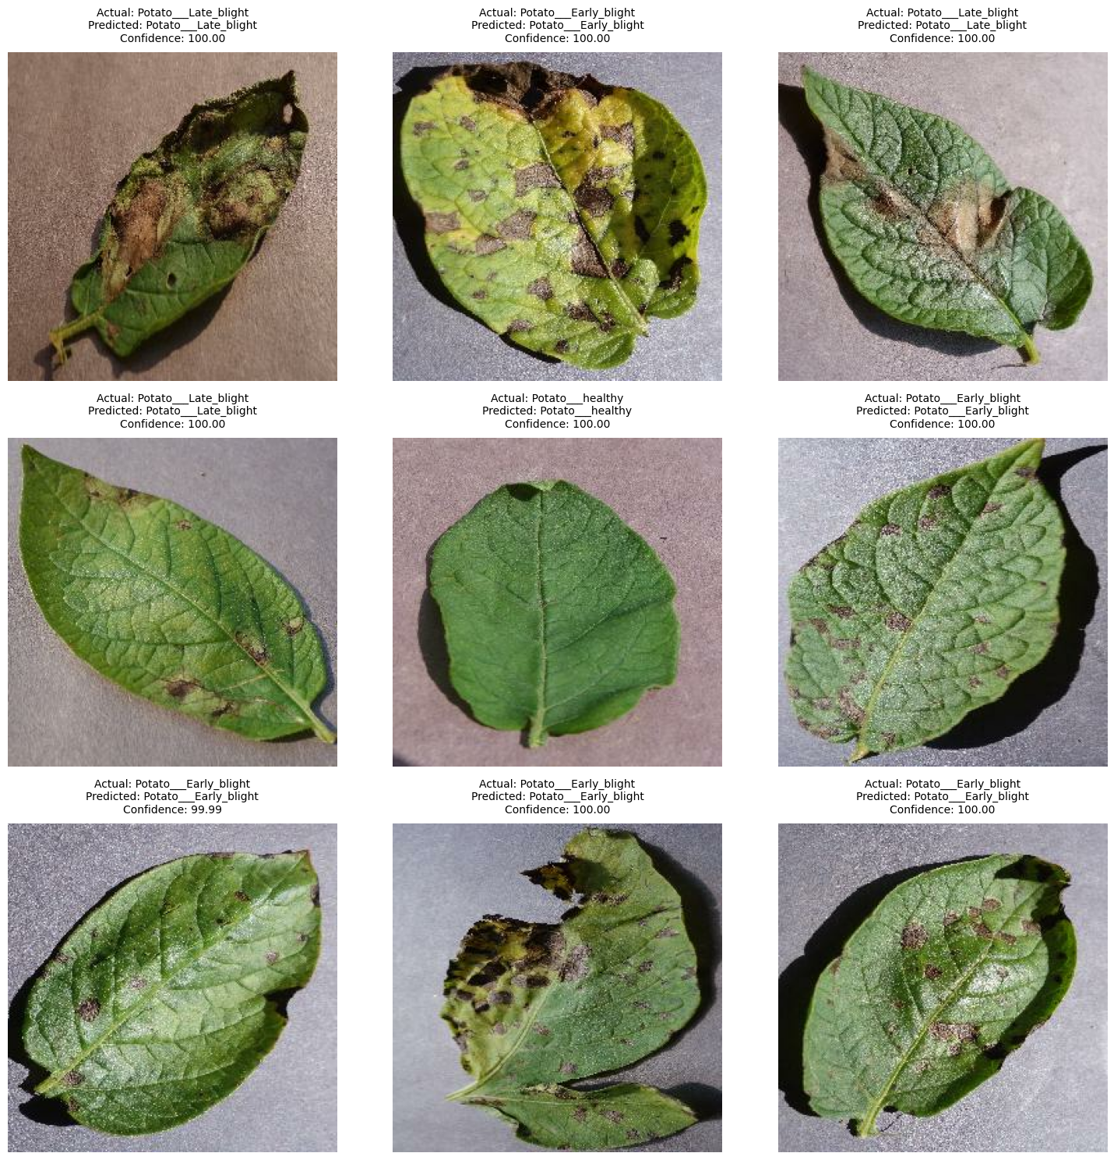

Actual vs. Predicted labels for potato leaf disease classification, with model confidence scores.

**Conclusion**

This project demonstrates the effectiveness of CNNs in identifying potato leaf diseases, achieving high accuracy across multiple classes. Combined with a well-designed data pipeline, image augmentation enhances the model’s robustness. The project underscores the potential of deep learning in agricultural applications, providing a tool that could assist in timely disease detection, thus benefiting crop management and reducing yield loss. Future work may involve expanding the dataset to include additional disease types and refining the model for deployment in field conditions.